In order to complete the Week 1 exercise, I erased the line that was used to draw a rectangle and I used “g.DrawEllipisis” to draw a circle in the bottom right.
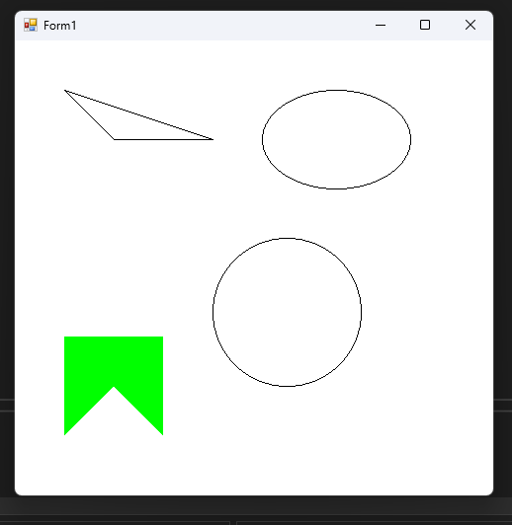
  - Week 1 Output

